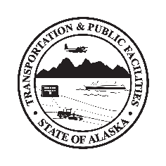
Department of Transportation & Public Facilities
Insert Building or Section Name here before printing

This worksite has controlled access due to COVID-19

This worksite is locked during business hours until further notice.
To meet with a section employee, please call the section’s point of contact:
Civil Rights Office | (907) 269-0848
Division of Facilities Services | (907) 269-0819
Finance | (907) 269-0835
Highway Data | (907) 269-0876
Human Resources | (907) 269-0893
Internal Review | (907) 269-0719
State Equipment Fleet | (907) 269-0787
Supply | (907) 269-0873
Deliveries/Pick-ups | (907) 269-0819

By recommendation of State Health Alerts, Workplace Policy, and DOT&PF COVID-19 Operating Plan, all Alaskans are advised to promote public health and fight COVID-19 by following public health guidance.

ALL VISITORS MUST SIGN-IN/OUT AT FRONT DESK

All building staff and visitors are required to

- Not enter if you have
  - COVID-19 symptoms
  - had contact with anyone you know has been diagnosed with COVID-19
  - had a positive-COVID test for active virus in the past 10 days
- Wear a cloth face covering if unable to keep 6 feet from others, while in halls, common areas and offices. Observe required distancing by following floor markings and placards throughout building.
- Use noncontact methods of greeting
- Cover coughs and sneeze into sleeve or elbow--not hand
- Use provided hand sanitizer or wash hands with soap & water for 20 seconds

State Health Alerts at coronavirus.alaska.gov
DOT&PF COVID-19 Operating Plan at web.dot.state.ak.us/comm/covid-office-operating-plan.shtml

