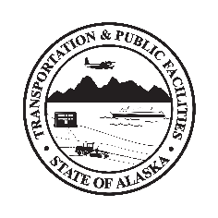
Department of Transportation & Public Facilities
Insert Building or Section Name here before printing

Vehicle Use

By recommendation of State Health Alerts, Workplace Policy, and DOT&PF COVID-19 Operating Plan, employees are advised to promote public health and fight COVID-19 by following public health guidance.

All users are required to

- Wear a cloth face covering if unable to keep 6 feet from others
- Prior to use, clean & disinfect commonly touched surfaces such as arm rests, door/grab handles, door/window controls, steering wheel, instrument panels, visors, gear shifters, seatbelt buckles & non-cloth seats with wipes provided
- While in vehicle, cover coughs and sneeze into sleeve or elbow--not hand
- Away from vehicle, avoid contact greetings such as handshakes/high-fives and wear a cloth face covering if unable to keep 6 feet from others
- Upon reentering vehicle or after refueling, use provided hand sanitizer to avoid contaminating previously-disinfected surfaces
- Upon returning vehicle, remove all wipes, trash, etc
- Replenish wipes & hand sanitizer as needed

State Health Alerts at coronavirus.alaska.gov
DOT&PF COVID-19 Operating Plan at web.dot.state.ak.us/comm/documents/COVID-Business-Plan.pdf

